For this assignment, I chose to do option 2, the stock exchange prediction. With the recent buzz on dogecoin and other crypto currencies, I thought it would be interesting to try and write an algorithm to predict the trend of the market. I was going to focus on dogecoin at first, but since it is still relatively new, I decided to look at bitcoin. I implemented the moving average algorithm that was provided to us, changing some of the data to be more applicable to my problem. I trained on 80 percent of the data, and then used that to create predictions for what was going to happen. I compared the predictions I got to the actual data on the graph. In the graphs below, the blue line represents the data that was trained, the green line represents the predicted data, and the orange line is the actual data. I wanted to see how the algorithm did with different amounts of data, so I ran the code using data from the last month, data from this year, data from last year, and data from 2018.

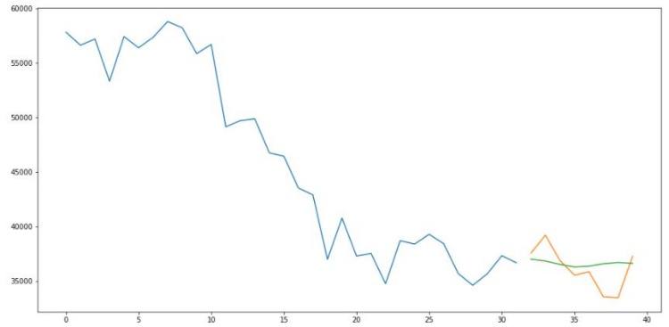

Predictions given data from the month of May

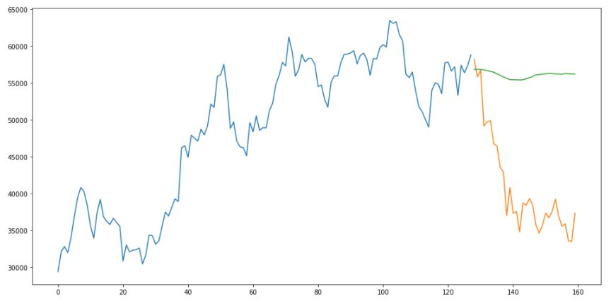

Predictions given data from this year

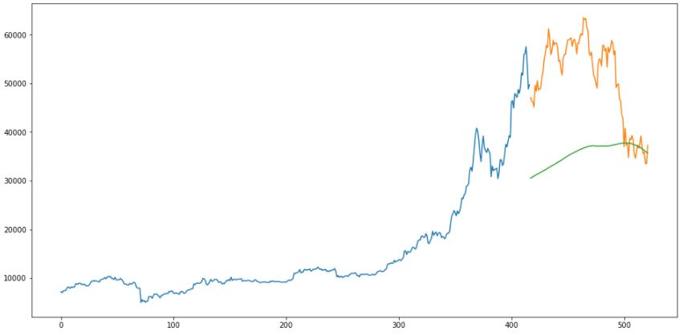

Predictions given data from last year

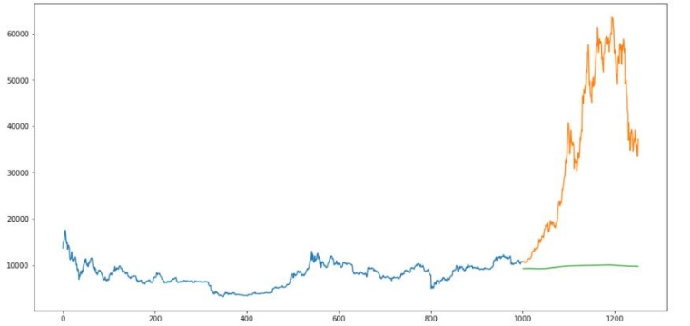

Predictions given data from 2018

One thing I noticed when comparing the graphs, is that as the algorithm is given more data, the predictions get worse. When looking at the predictions given data from last month, the algorithm does a good job of predicting what will happen. However, looking at data from 2018, the algorithm is very different in comparison to the actual data. This may be credited to the boom that started to happen around the same time.

Jupiter Notebook link: https://github.com/akwasiboachie/final_project_349